PRESS RELEASE
[
Subject: AFRIEF AND KHADAR HOLDING GROUPLAUNCH JOINTCOOPERATION IN CHAD

Date: February, 2019

For release: Immediate

Media to contact: Baba Yunus Muhammad & Fatime Souckar Djibrine

Africa Islamic Economic Foundation(AFRIEF), an independent Non-Governmental organization (NGO) in the Republic of Ghana that provides a range of advisory, research, policy, project development and field-building activities in Africa; and Khadar HOLDING GROUP, company a market driven firm focused on Agribusiness, Islamic economy development, Commodity trading and technologies have announced the signing of a Memorandum of Understanding (MOU), with a general objective to have an association to support the development of social and infrastructure projects in the Republic of Chad covering agro-industry, housing, water and sanitation and smart cities,.

Combining expertise in project planning, finance, economics and operations with a sophisticated knowledge of implementation strategies, the two organizations have also agreed to jointly launch a wide range of projects involving research and capacity development, and strategic support for transformative strategies among community stakeholders, anchor institutions, and key policymakers in the Republic of Chad.

Mr. Baba Yunus Muhammad Comments:

Mr. Baba Yunus Muhammad, President of Africa Islamic Economic Foundation (AFRIEF) has this to say: “this collaboration marks an exciting chapter for AFRIEF as it will inject its international experience, network and strength into the service portfolios and capabilities of Khadar Market and Farms to deliver services in ethical project finance, international trade and project development, institutional, technology and human development; and to support the Government, public and private sector organizations of the Republic of Chad to accelerate the growth and development of Chad. We believe the two organizations have complementary capabilities and we are very excited at the power of combining these to create a full-service portfolio leveraging a larger pool of international and local talents and expertise. No doubt, this relationship will create strong synergies in both project and talent development, and it will help to accelerate AFRIEF’s mission of shifting the prevailing paradigm of economic development in Africa - and of the economy as a whole - toward a new system that is ethical, place-based, inclusive, collaborative and ecologically sustainable”.

Hajiya Fatime Souckar Djibrine Comments:

Hajiya Fatime Souckar Djibrine, CEO of Khadar Holding Group has this to say: “This partnership with AFRIEF is in line with our mission to address Chad’s critical socio-economic and infrastructure challenges such as climate change, energy demands, water and food shortages, mass urbanization, economic and social development. To address these challenges effectively and deliver lasting economic and social development, the Republic of Chad needs the collective leadership, experience and creativity of the international infrastructure and finance community. This partnership therefore provides us with the rare opportunity to combine our collective experience and expertise, connection and network to propel Chad’s rapid economic and social development.

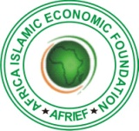

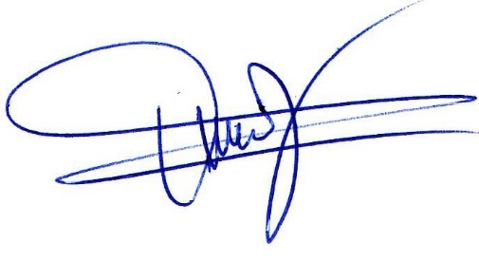
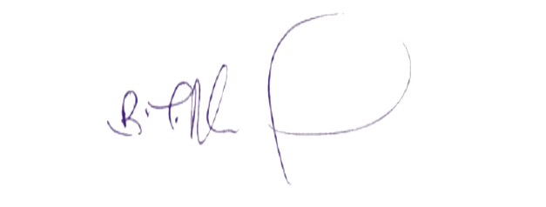

Baba Yunus Muhammad President
Africa Islamic Economic Foundation
Al Furqan Building
Tamale, Ghana
Email:info@afrief.com
Website:www.afrief.com
Cell: +233 243 65 54 46.
What’s up: +234 80 96 34 27 95

Mme Dago Fatime Souckar Terab
Chief Executive Officer
Khadar Holding Group
N’Djamena, Chad.
Email: fatimesouckar@gmail.com
Website: www.afrief.com
Cell: +23565215111

Courtesy:

AFRIEF MEDIA UNIT
Tamale, Ghana.

